Project - High Level Design
On
Autonomous Logistics Researcher Agent
Course Name: Agentic AI

Institution Name: Medicaps University – Datagami Skill Based Course

Student Name(s) & Enrolment Number(s):
Sr no | Student Name | Enrolment Number
1 | Dhruv Rai | EN22CS301335
2 | Devyani Choudhary | EN22CS301328
3 | Cheshta Patidar | EN22CS301293
4 | Bhavya Jain | EN22CS301268

Group Name: Group 01D3
Project Number: AAI-25
Industry Mentor Name: Mr. Ashwin Krishnan C K
University Mentor Name: Prof. Maya Yadav Baniya
Academic Year: 2025-26

Table of Contents
1. Introduction 3
1.1 Scope of the Document 3
1.2 Intended Audience 3
1.3 System Overview 3
2. System Design 4
2.1 Application Design 4
2.2 Process Flow 4
2.3 Information Flow 6
2.4 Components Design 7
2.5 Key Design Considerations 9
2.6 API Catalogue 9
3. Data Design 9
3.1 Data Model 9
3.2 Data Access Mechanism 10
3.3 Data Retention Policies 10
3.4 Data Migration 10
4. Interfaces 10
5. State and Session Management 11
6. Caching 12
7. Non-Functional Requirements 12
7.1 Security Aspects 12
7.2 Performance Aspects 12
7.3 Reliability 12
7.4 Usability 12
8. References 12

Introduction

Scope of the document

This document provides a comprehensive High-Level Design (HLD) for the Autonomous Logistics Researcher Agent. It outlines the system architecture, major components, workflows, data handling mechanisms, and design principles. The document serves as a blueprint for:
- System development
- Implementation planning
- Performance evaluation
- Future scalability and enhancements
It ensures that all stakeholders have a clear understanding of how the system will function at a macro level.

Intended Audience

This document is intended for multiple stakeholders:
- Developers → To understand system architecture and implementation flow
- Project Mentors → To evaluate design quality
- Stakeholders → To understand system capabilities
- Testers → To design test cases
- Future Maintainers → For system upgrades

System overview

The Autonomous Logistics Researcher Agent is an AI-driven system that automates the process of gathering, analyzing, and summarizing logistics-related information. Traditionally, logistics research requires:
- Manual searching
- Reading multiple sources
- Summarizing insights
This system eliminates manual effort by:
- Automatically searching the web
- Extracting relevant data
- Generating structured summaries
- Storing results for future use The system leverages:
- Large Language Models (LLMs) for intelligence
- LangChain / CrewAI for orchestration
- Search APIs for real-time data retrieval

System Design

Application Design

The system is designed using a modular and scalable architecture to ensure flexibility and maintainability. Architecture Style
- Agent-based architecture
- Microservice-friendly design
- Loosely coupled components

Core Layers
- Presentation Layer
- User interaction
- Query input &
- Output display

- Application Layer
- Agent orchestrtion

- Processing Layer
- LLM-based reasoning
- Data summarization

- Data Layer
  - Storage of results
  - Knowledge base

Process Flow

The system follows a multi-step intelligent workflow:

Step 1: User Input
- User enters a logistics-related query
- Example: “Latest trends in supply chain optimization”

Step 2: Query Understanding
- LLM interprets user intent
- Extracts keywords and context

Step 3: Task Planning
- Agent decides:
- What to search
- Which tools to use
- How many sources to fetch

Step 4: Web Search Execution
- Search APIs are triggered
- Multiple sources are retrieved

Step 5: Data Extraction
- Relevant content is filtered
- Noise and irrelevant data removed

Step 6: LLM Processing
- Data is analyzed
- Summarization is performed
- Key insights are generated

Step 7: Output Formatting
- Results are structured into readable format
- Bullet points / paragraphs

Step 8: Storage
- Final output is stored in a knowledge repository

Step 9: Response Delivery
- User receives the summarized answer

Information Flow

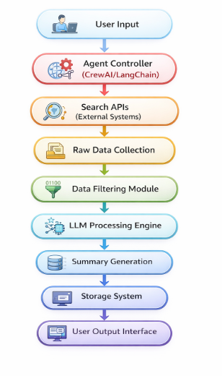

Key Characteristics:
- Bidirectional flow (feedback possible)
- Real-time processing
- Multi-source aggregation

Components Design

1. User Interface
- Web-based or CLI-based interface
- Accepts natural language queries
- Displays structured outputs

  - Agent Orchestrator (CrewAI / LangChain)
- Core brain of the system
- Manages multiple agents
- Defines workflows and execution order Responsibilities:
- Task decomposition
- Tool selection
- Workflow execution

  - Search Module
- Connects to external APIs
- Retrieves real-time logistics data Features:
- Multi-source search
- Query optimization
- Result ranking

  - LLM Processing Engine
- Uses APIs like OpenAI Performs:
- Text summarization
- Insight extraction
- Context Understanding

  - Data Storage / Knowledge Base
- Stores processed outputs
- Can use:
- Text files
- Databases
- Vector databases (optional)

  - Memory Module (Optional but Advanced)
- Stores previous queries
- Enables context-aware responses

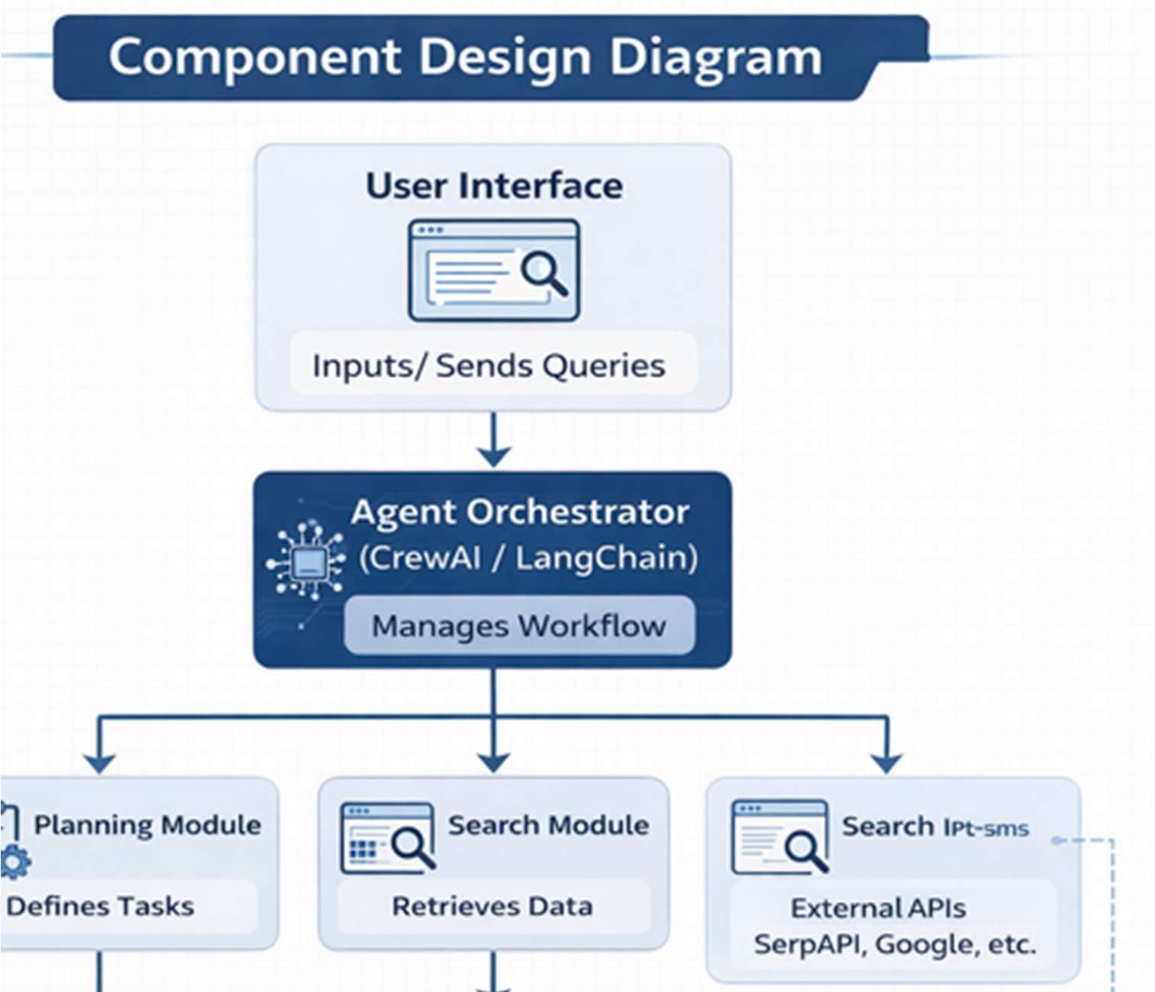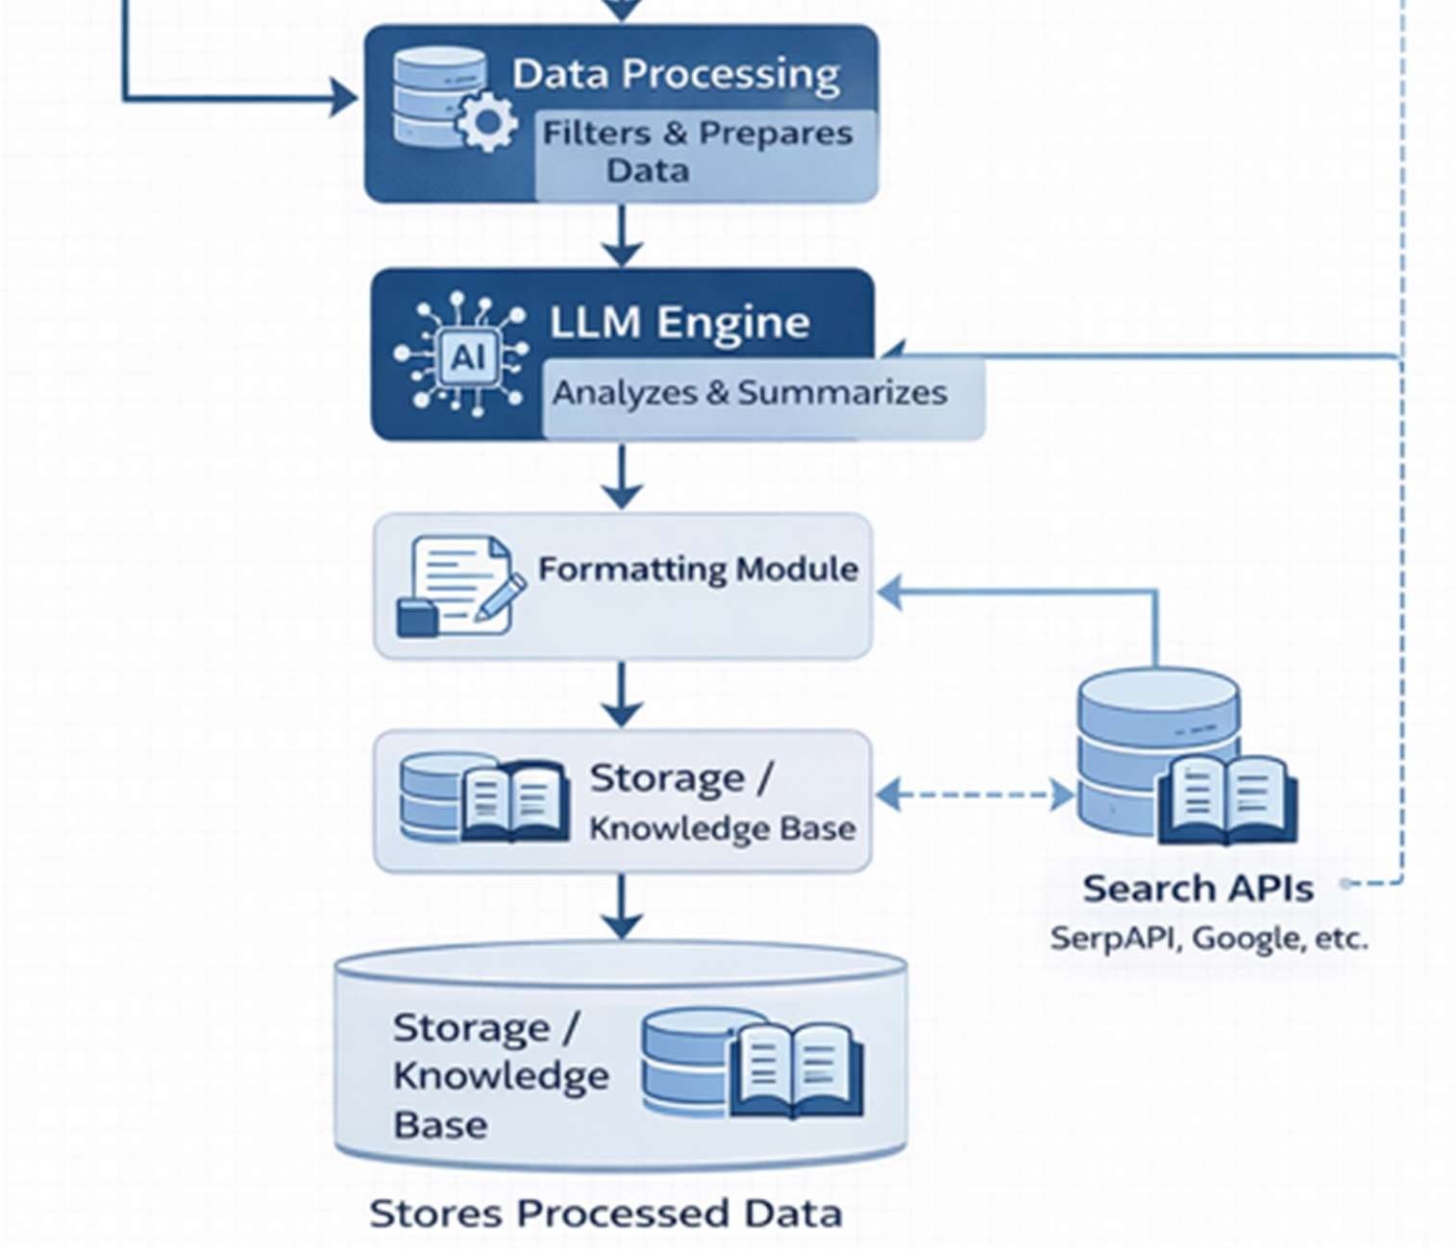

Key Design Considerations

1. Scalability
- System should handle multiple users
- Modular design supports scaling
  - Accuracy
- Reliable sources must be prioritized
- LLM hallucination should be minimized
  - Performance
- Response time should be minimal
- Efficient API usage
  - Cost Optimization
- Reduce unnecessary API calls
- Use caching
  - Maintainability
- Clean modular design
- Easy to update components

API Catalogue

API | Description | Usage
LLM API | Text generation | Summarization
Search API | Web search | Data retrieval
Storage API | Data saving | Knowledge base

Data Design

Data Model

The system uses structured and semi-structured data: Entities:
- User Query
- Search Results
- Processed Data

Data Access Mechanism
- REST APIs
- Python-based SDKs
- LangChain integrations

Data Retention Policies
- Important summaries are stored permanently
- Temporary data is deleted
- Logs maintained for debugging

Data Migration
- Data can be exported
- Cloud integration possible
- Backup mechanisms supported

Interfaces

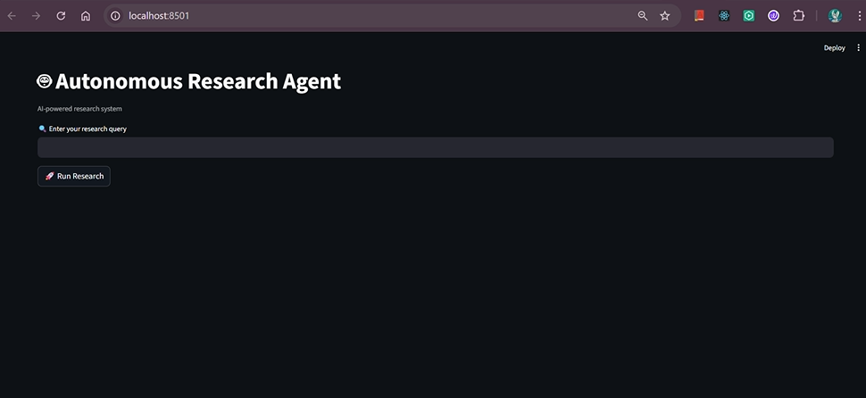

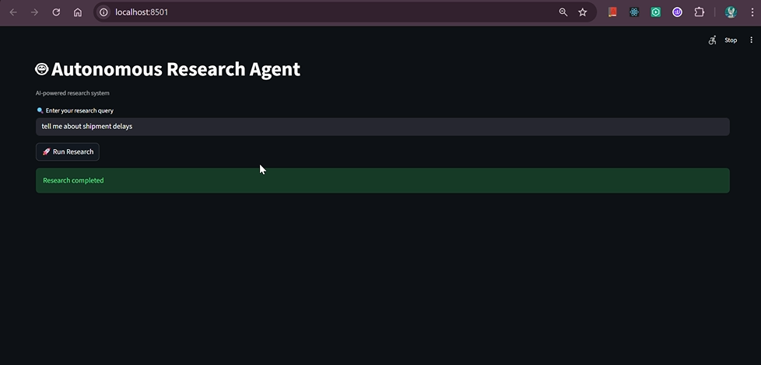

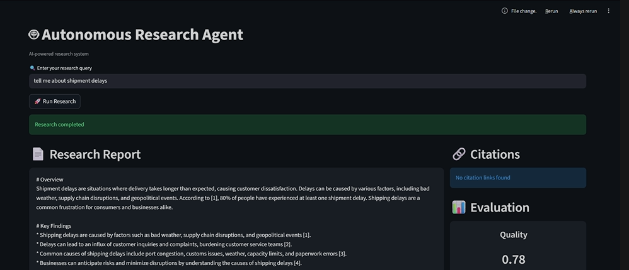

Internal Interfaces:
- Agent ↔ LLM
- Agent ↔ Search Module
External Interfaces:
- User Interface
- Third-party APIs

State and Session Management
- Each query handled independently
- Session maintained temporarily

Caching

Purpose:
- Reduce latency
- Minimize API usage Techniques:
- In-memory caching (Redis)
- Query-result caching

Non-Functional Requirements

Security Aspects
- Secure API keys
- Data encryption
- Access control

Performance Aspects
- Fast processing (< few seconds)
- Efficient parallel execution
- Optimized API calls

Reliability
- System should handle failures
- Retry mechanisms

Usability
- Simple interface
- Clear output format

References
- LangChain Documentation
- CrewAI Documentation
- OpenAI API Documentation
- Research Papers on Agentic AI

